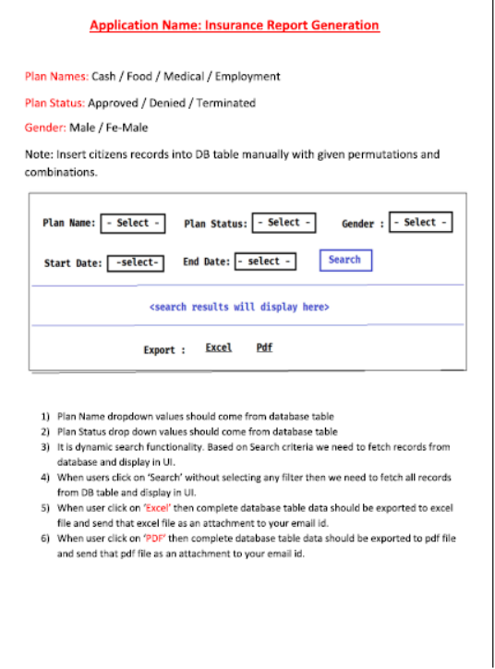

Analysis:-
=====================================
DB Table Name : CITIZEN_PLANS_INFO
=====================================

CITIZEN_ID INT PRIMARY KEY
NAME VARCHAR
EMAIL VARCHAR
PHNO INT
GENDER VARCHAR
SSN INT
PLAN_NAME VARCHAR
PLAN_STATUS VARCHAR
PLAN_START_DATE DATE
PLAN_END_DATE DATE
CREATE_DATE DATE
UPDATE_DATE DATE

=================
Java Components
=================

CitizenPlan.java (c) // Entity

CitizenPlanRepo.java (I) // Repository

@Query("select distinct(planName) from CitizenPlan")
public List<String> getUniquePlanNames( );

@Query("select distinct(planStatus) from CitizenPlan")
public List<String> getUniquePlanStatus( );

DataLoader.java (c) => To insert data into db table (Runner)

SearchCriteria.java => To get search form data (binding)

CitizenPlanService.java (I)
CitizenPlanServiceImpl.java (c)

a) public List<String> getPlanNames( )
b) public List<String> getPlanStatus( )
c) public List<CitizenPlan> searchCitizens(SearchCriteria criteria)
d) public void generateExcel(HttpServletResponse response)
e) public void generatePdf(HttpServletResponse response)

CitizenPlanController.java (c)

(a) public String index(Model model); // GET
(b) public String search(CitizenPlan req, Model model); // POST
(c) public void downloadExcel(HttpServletResponse response); //GET
(d) public void downloadPdf(HttpServletResponse response); //GET

EmailUtils.java (c)
(a) public boolean sendEmail (File file);

==========
DB Setup
==========

(1) Install MySQL DB server
(2) install mysql workbench (client)
(3) Connect with DB server using workbench
(4) Create database using below queries

create database jrtp24;
use jrtp24;
show tables;

=============
Development
=============

Step-(1) Create Spring starter project with below dependencies

a) web-starter
b) data-jpa
c) mysql-driver
d) thymeleaf
e) apache-poi
f) open-pdf
g) mail-starter
h) devtools

<dependency>
<groupId>org.apache.poi</groupId>
<artifactId>poi-ooxml</artifactId>
<version>4.1.0</version>
</dependency>

<dependency>
<groupId>com.github.librepdf</groupId>
<artifactId>openpdf</artifactId>
<version>1.3.8</version>
</dependency>

Step-2) Configure data source properies in application.propertie file

Step-3) Create Entity class & Repository interface

Step-4) Create DataLoader class as Runner to populate data into DB table

Step-5) Create SearchCriteria class to map search form data

Step-6) Create Service interface & Impl class

Step-7) Create Controller class

Step-8) Create View File (src/main/resources/templates)

Step-9) Develop presentation logic with thymeleaf + bootstrap

